Industrial Storage Service A

Migration Process

**Version Control**

All information given under this version over rides all and any kind of offers, assumptions, deliverables and contracts, given under any previous version. All previous versions of the subject Proposal stand null and void.

**Seller Restrictions**

The data contained in this document shall not be disclosed and shall not be duplicated, used, or disclosed in whole or in part for any purpose. If a contract is awarded to chosen parties as a result of or in connection with the submission of this data, the client or prospective client shall have the right to duplicate, use, or disclose this data to the extent provided in the contract. This restriction does not limit the client’s or prospective client’s right to use the information contained in the data if it is obtained from another source without restriction. The data subject to this restriction is contained in all marked sheets.

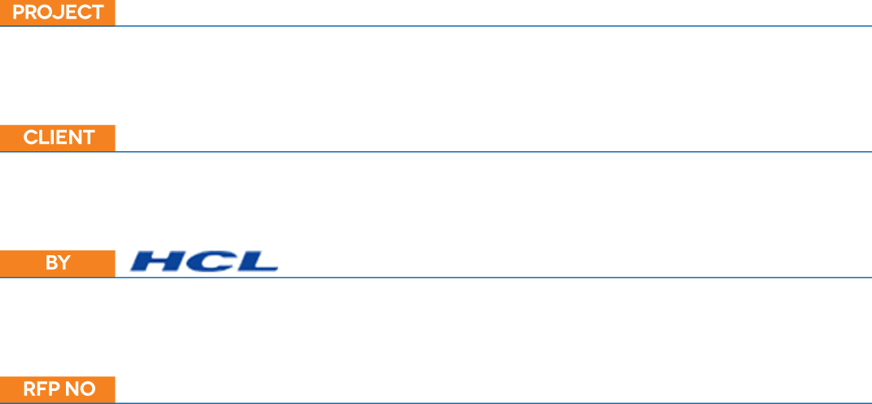

|  |  |
| --- | --- |
| NAME | Naresh D |
| DESIGNATION | ASSOCIATE CONSULTANT |
| PHONE NUMBER | +919962587172 |
| MOBILE NUMBER | +919962587172 |
| FAX NUMBER |  |
| EMAIL | naresh.deenadayalan@hcl.com |

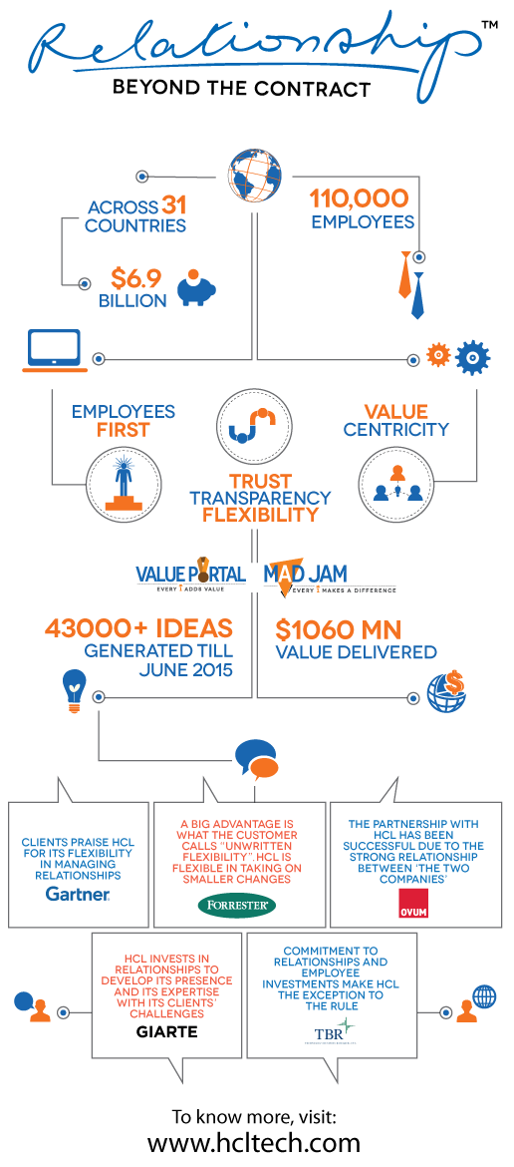

**TABLE OF CONTENTS**

* + - 1. Share Creation
      2. AD Groups Creation
      3. DFS Creation
      4. Migration – Data copy and Cutover
      5. Migration – Share in Faros

1. Share Creation

* New shares will be created through interface script using option 1 on Gluster server sesdel0206
* Login to the server. Go to /root/manageshares/

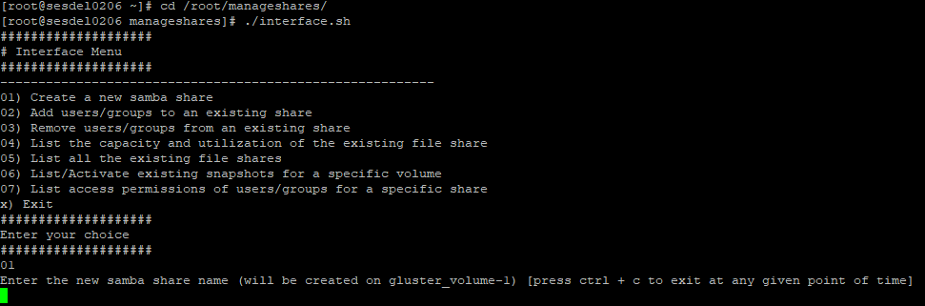

* Enter the new smba share name and description which you want to create.

Once entired, relevenat groups in AD& DFS path will also be crated.

Share has been provisioned.

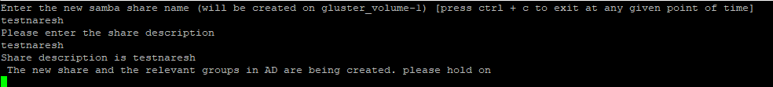

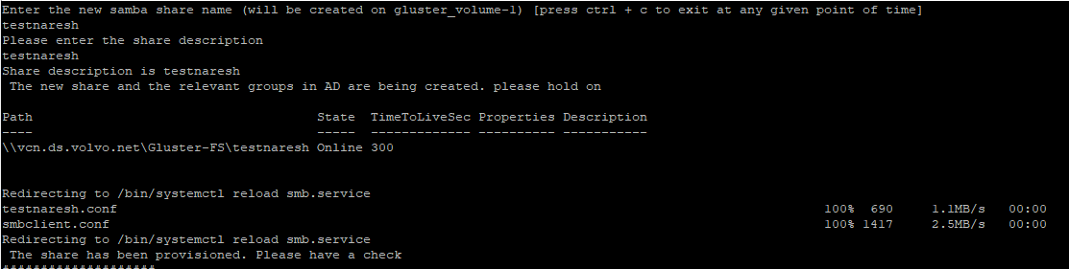

* Following security groups will be created

Share folder object and share

Security Group for read permission (-R group)

Security Group for write permission (-X group)

**Example:**



**New Share:**

DFS Path: \\vcn.ds.volvo.net\Gluster-FS\VPT-SDE-AVD3562

UNC Path: \\148.138.12.137\vpt-sde-avd3562

1. AD Security and User Groups Creation
   1. AD “Shared Folder” permission

* New shares AD Security and user groups will automatically create as a part of interface script
* For Migration Check User/Group and Permission on Existing “Shared Folder” in AD and setup same User/Group with permission on New “Shared Folder” in AD.
* New Serivce A “Shared Folder” are on “vcn.ds.volvo.net\VolvoGroup\SDE\Storage\GlusterShare”

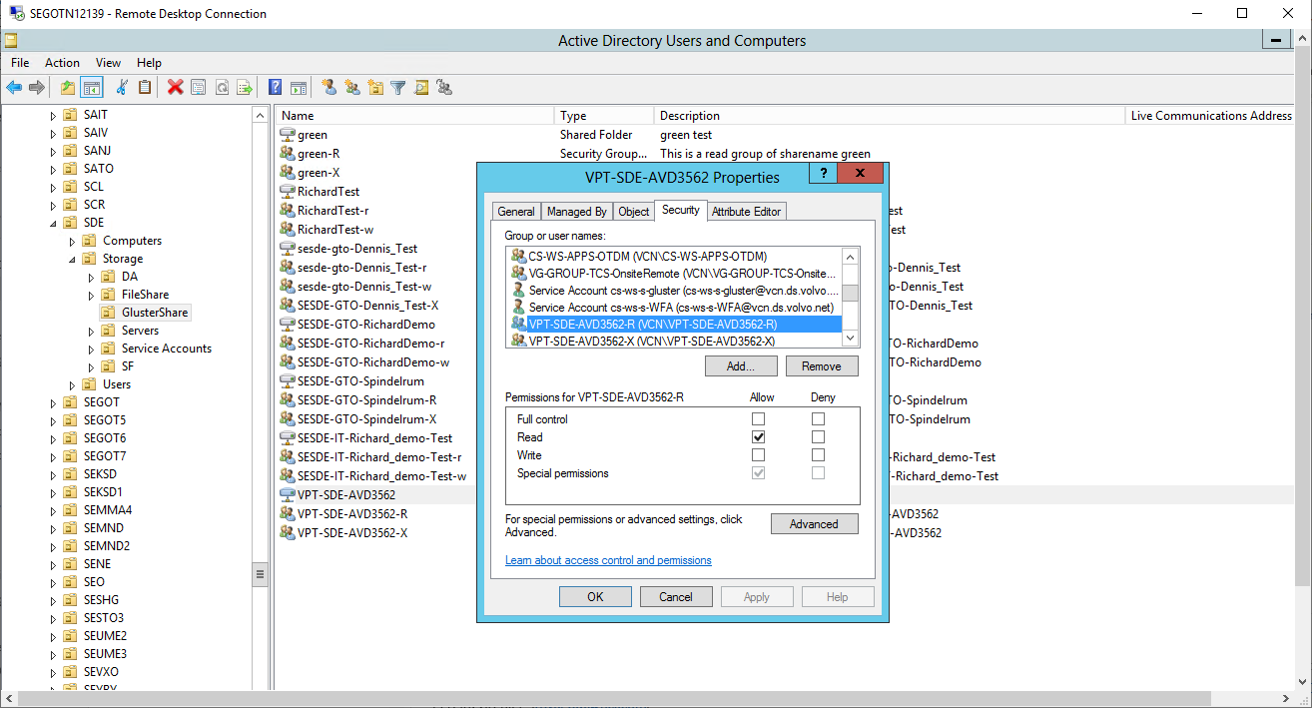

* 1. User group R and X permission
* Replicate the Users/Groups on newly created Read (-R) and Write (-X) AD groups

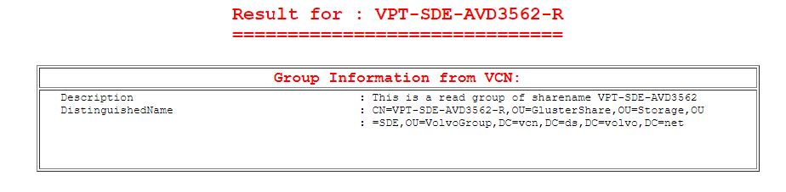

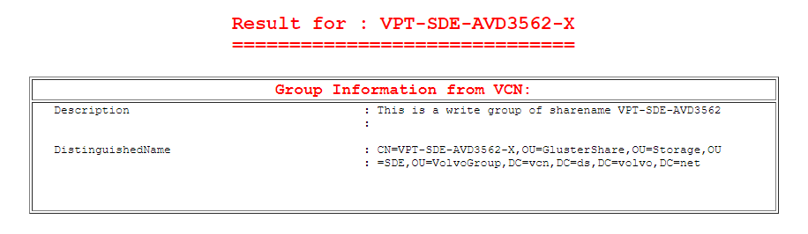

1. DFS CREATION
   1. DFS Target folder creation for the new shares.

* New folder for each share to be migrated is created under IT-SDEroot namespace. This is also created at as a part of interface script.

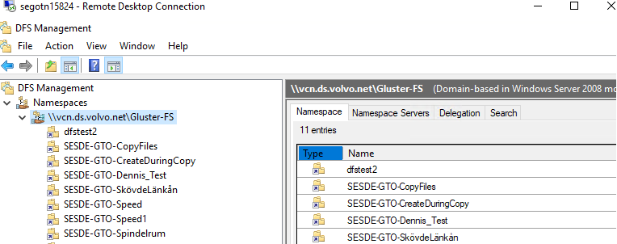

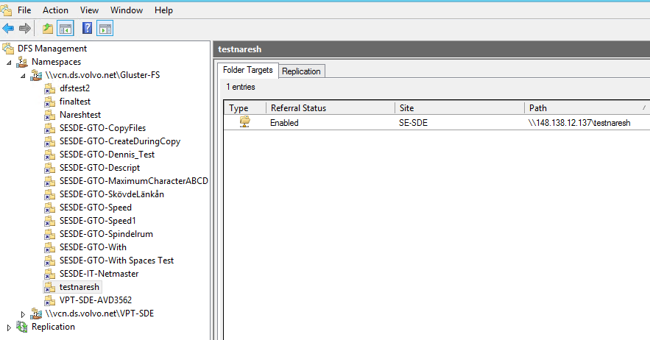

* 1. Mapping the CIFS share to the New DFS Target
* Newly created share is mapped to the DFS folder target. Target Path will be Enabled via Default when DFS path is created through interface script

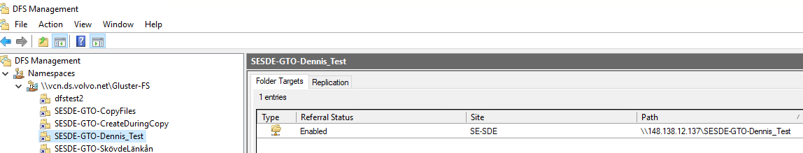

1. Migration – Data copy and Cutover
   1. Data Rsync

* We will mount the existing/old share file system on Gluster server and start the rsync from existing file system to New Gluster File sytem.

Example:

# mount -vvv -t cifs '\\148.138.2.72\vpt-sde-avd3562\' /VPT-SDE-avd3562 -o vers=1.0,username=cs-ws-s-gluster,password=3xf?ld088JEW9n-

# rsync -avzhp --progress /VPT-SDE-avd3562/ /volumes/gluster_volume-1/VPT-SDE-AVD3562/

* 1. Final Cutover
* Start the final rsync - Incremental copy
* Stop the share from old Netapp storage and rename DFS Path for OLD shares (DON’T REMOVE/DECOMM)
* Change the DNS IP of old storage sesdex001 & sesdex002 pointing to Gluster Storage CTFB IP 148.138.12.137 and refresh DNS records
* Start publishing shares in network my places.

1. Migration – Share in Faros

* Data Rsync& Final Cutover will be same for Share in Faros also(4.1& 4.2)
* We will be requesting faros team to rename the exisiting share until we confirm to remove/delete the OLD share